Gravity and Orbits

1. In the picture below, draw how you think Earth moves.

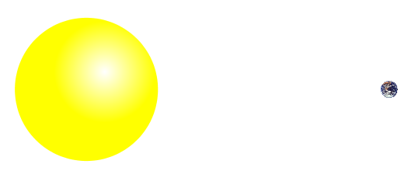

2. Draw a picture using arrows to show what you think the forces might be on the Earth and the Sun.

You can draw a longer arrow to represent a big force, and a shorter arrow to represent a small force.

3. Draw a picture of how you think the Earth would move if these forces were not there.



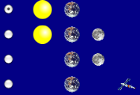

1. Open the ***Gravity and Orbits*** simulation. Take 5 minutes to **explore** how the Earth, Moon, and the Space Station move. Explain what you found.
2. Compare the motion of the **Earth moving around the Sun** with the **Moon moving around the Earth**.

|  |  |
| --- | --- |
| **Earth moves around the Sun**  Your Picture  Your Description | **Moon moves around the Earth**  Your Picture  Your Description |
| What are some things you find that are the **same** about these motions?  What are some things you find that are **different** about these motions? | |

**Part 2: Understanding Gravity**

1. For the Sun and Earth system:
   1. **Draw** the path of the Earth with **Gravity ON** and **Gravity OFF**

**GRAVITY ON GRAVITY OFF**

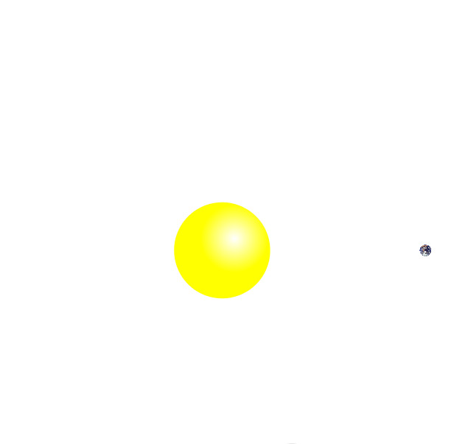

* 1. **Why** is gravity important?

1. **Explore** the simulation to find out how you can change the force of gravity and observe what happens.

Describe what you found.

1. **Draw** the Sun’s gravitational pull on the Earth **Draw** the Earth’s gravitational pull on the Sun

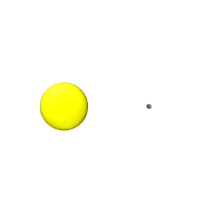

Why do you think the Earth moves, but the Sun does not move?

1. Return to your pictures in Questions 2 and add arrows to **show the force of gravity**. Label them with “Gravity Force”.

1. **Play** with the sim to find ways to change the length of the blue gravity force arrows. Collect your results in the table below.

a) Fill in an **ACTION** below and **write** whether or not the gravitational force increases or decreases.

|  |  |  |
| --- | --- | --- |
| **ACTION** | **Gravity Force Increases** | **Gravity Force Decreases** |
| Put star and planet closer together |  |  |
|  |  |  |
|  |  |  |
|  |  |  |
|  |  |  |

b) What can affect the strength of gravitational force? What can you conclude from the results in your table?

1. Comparisons:

a) **Compare** these two cases:

**CASE 1** **CASE 2**

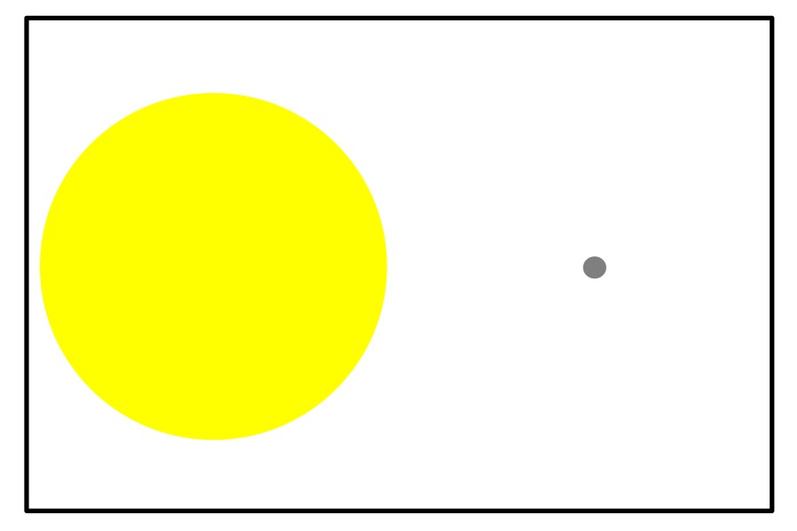 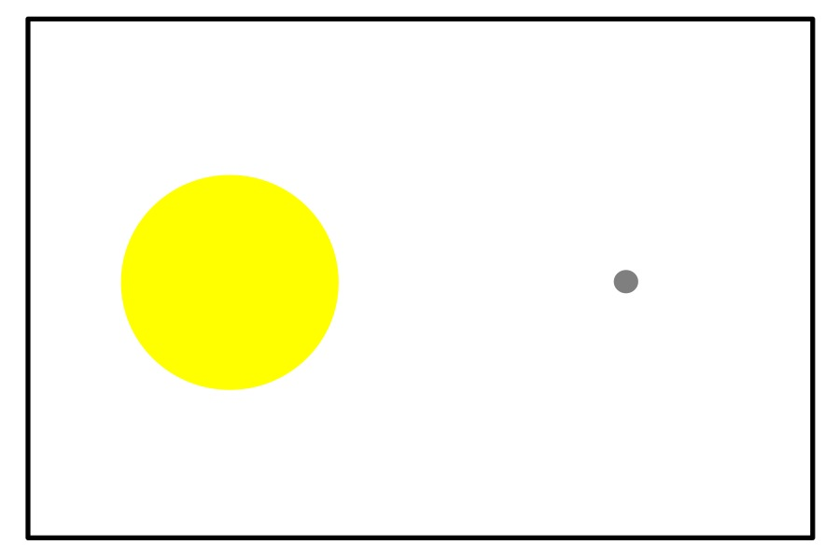

What was changed between Case 1 and Case 2?

**Draw** the force of gravity on the Earth in each case.

b) **Compare** these two cases:

**CASE 1** **CASE 2**

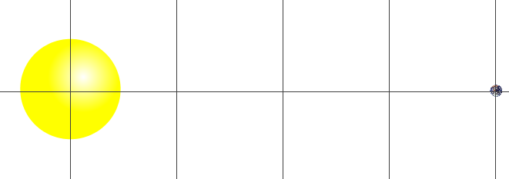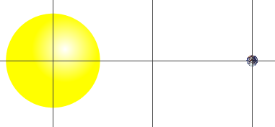

What was changed between Case 1 and Case 2?

**Draw** the force of gravity on the Earth in each case.

**Part 3: Gravity and Motion**

1. Fill in the table to help describe what you find out.

|  |  |  |  |
| --- | --- | --- | --- |
| **How can you….** | Explain what you changed | Draw the motion paths | What other changes do you notice? |
| **...make the Moon**  **go around the Earth in a bigger circle?** |  |  |  |
| **...make the Earth**  **take more time to go around the Sun?** |  |  |  |
| **...make the Earth**  **take less time to go around the Sun?** |  |  |  |

1. In the picture below, draw how you think the Earth and the Moon move.

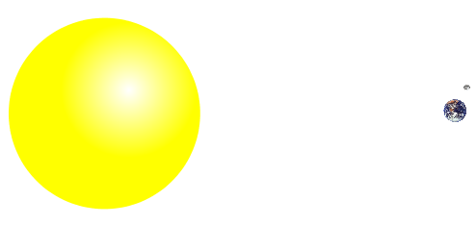

1. On the picture above, show the gravity forces on the Earth, Sun and the Moon.

3. Fill in the following table with your predictions and a drawing of each case.

|  |  |  |
| --- | --- | --- |
| **Predict** what would happen to the gravity force if you… | Gravity **Increases**, **Decreases** or **Stays the Same**? | **Your Drawing** |
| ...increase the size of the Star |  |  |
| ...move the star and the planet away from each other |  |  |
| ...decrease the size of the Planet |  |  |
| ...move the Star and Planet closer to each other |  |  |

4. Show in the picture below how you think the Earth and Moon would move if there were no gravity forces at all.



Explain why you think the Earth and Moon would move in this way.